Project «Revolution»
Revolution of RPG game.
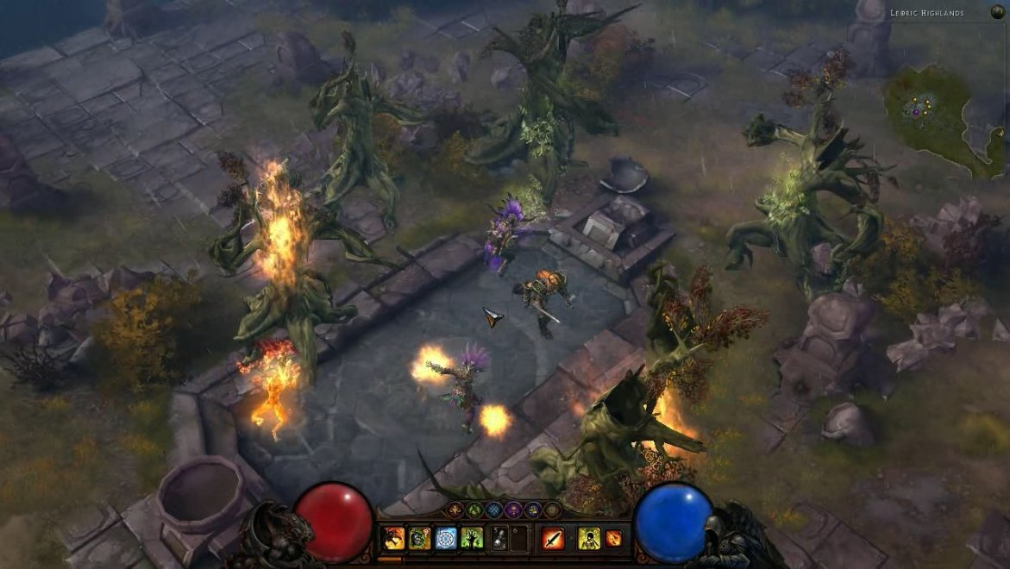
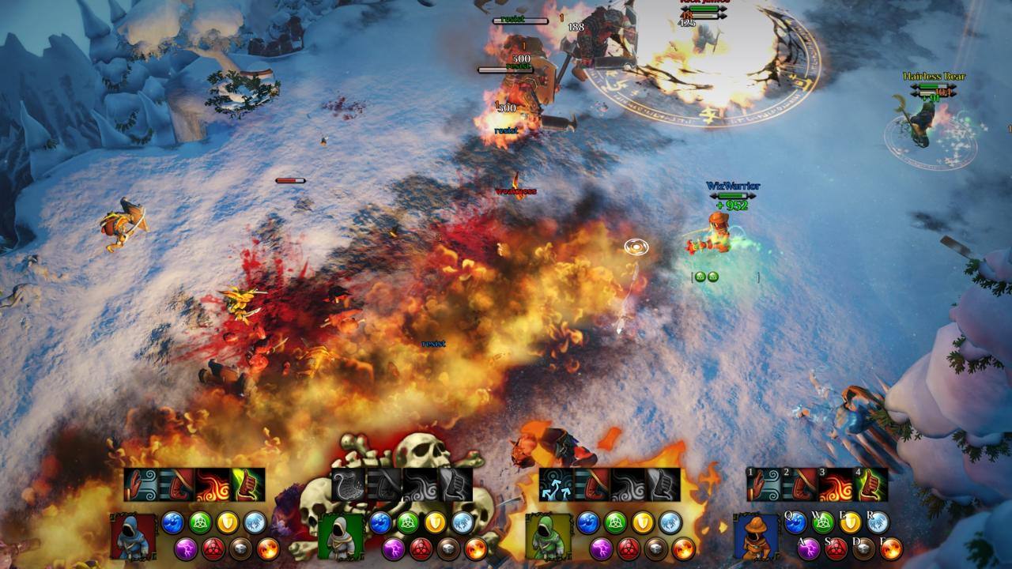
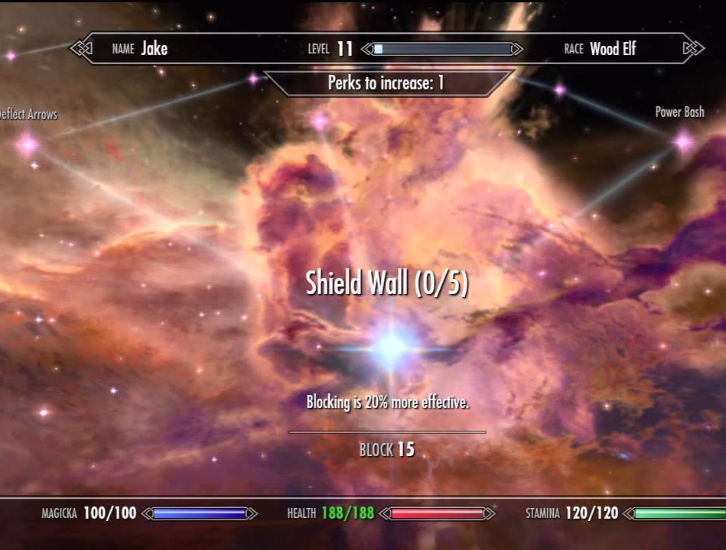
Genre: 3rd person fixed camera RPG.
Target Audience: T for Teen.
Controls: Mouse & Keyboard and controller.
Thematic Setting: Medieval fantasy – swords, knights, dragons.
Tech Stack: Unity 5+, Blender, Gimp, Inkscape, Audacity.
Platform(s): Steam.
Game Moment: 2 minutes of simple lever flow, basic combat (hitting and taking damage) with multiple enemy types.

